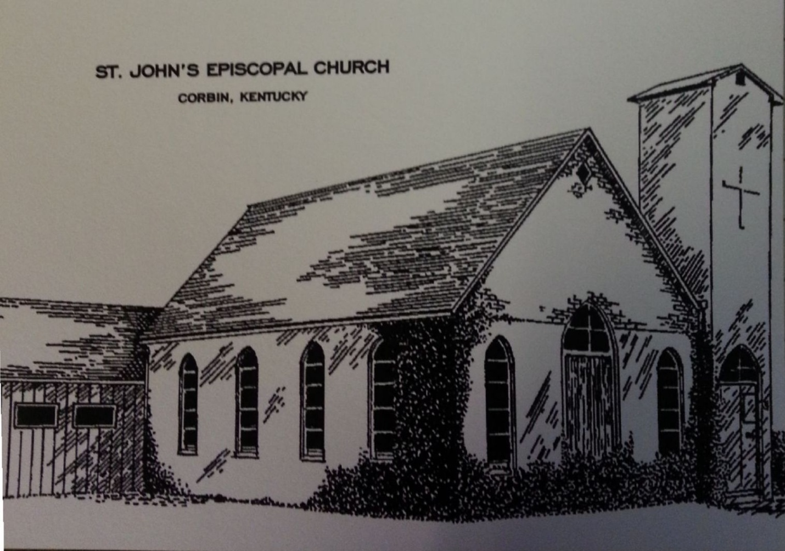
Annual Report
St. John’s Episcopal Church
701 Engineer St, PO Box 1512
Corbin, KY 40702

January 5, 2014

Annual Meeting
January 5, 2014

Members of the Parish who are sixteen years of age or older and are confirmed
communicants in good standing

Approval of the Minutes – Annual Meeting

Treasurer’s Report
Approval of 2014 Budget

Nominating Committee Report
Election of 2 Vestry Members
Candidates for 3-year term
Steve Gilbert
Doug Thelen

Election of 3 Delegates to the 2014 Diocesan Convention (February 20-22, 2014)
Candidates
      - Billy Hibbitts
      - Gay Nell Conley
      - Bruce W. Cory

Report from The Rev. Rebecca S. Myers, CSW, Priest-in-Charge

Friends,

First of all, thank you for your kindness, care and warm welcome. I began my service with you on September 1, spending two days each week working on parish business, although I am usually in Corbin four days each week. One day is my Sabbath day. Thank you for allowing me to serve you and to be your priest. The following are highlights from my time with you.

Community Relations
- Use of social media. Each week, I post a short meditation with announcements of upcoming activities, as well as posting my sermons. These items are sent as emails and posted on our Facebook and Twitter pages. Mary Swinford monitors and posts on our Pinterest account
- We hosted a meeting of the Ministerium and participated in the community Thanksgiving Service
- I regularly send news of our events to the Times-Tribune
- I have joined and participate in Rotary Club activities
- In 2014, I will prepare at least two meditations for WCTT Radio station
Pastoral Care
- I routinely make visits to those parishioners who are homebound, taking communion to them at least once a month.
- Working with Mary Swinford, I write notes to people who visit the church. We have a process of writing to each person a total of three times over three months.
- For parishioners who cannot make our services, bulletins are sent weekly.
- Use discretionary funds to assist people requiring help, both those within the parish and those who call or visit. Kroger’s cards are given or checks written directly to a utility or housing organization.
Worship
- Special services for various months, such as Latin American Heritage Month and Native American Heritage Month.
- Guest Preacher in November – The Rev. Brandt Montgomery.
- All Saints’ Day reading of names of the deceased.
- Honor Veterans and those serving in the Military around Veterans’ Day.
- Created spreadsheet to assist in planning services throughout the year.
Christian Formation
- Planned Adult Forum topics and recruited leaders for each series. Fall series were on Radical Welcome, and End-of-Life issues.
- Supported Godly Play for children and helped recruit additional storytellers and doorkeepers.
Diocese
- Participate in monthly supervision meetings as a Network Priest, as well as monthly webinars.
- Participated in Diocesan Leadership Training.
Sr. Warden Annual Report from Bruce W. Cory

Vestry Accomplishments
- Transitioned St. John's from the Small Church Ministry Consortium to the Network for Pastoral Leadership
- Said goodbye and thank you to the Rev. Margaret Shanks for her period of service with St. John's as clergy-in-charge
- Worked with the Diocese of Lexington to discern the next phase of ministry at St. John's
- Interviewed and issued a call to the Rev. Rebecca Myers as priest-in-charge at St. John's and initiated a shared ministry with St. Agnes House, at which the Rev. Rebecca Myers serves as executive director
- Renovated the rectory as a suitable home for a resident minister
- Hosted a table and distributed free bottled water at the annual Native American Heritage Festival
- Hosted the regional Diocesan Leadership Training and had several members of the vestry and congregation participate in the Leadership Training

Future Opportunities
- Transition the Rev. Rebecca Myers from 1/3 time to ½ time as clergy-in-charge
- Review and revise the parish mission statement
- Become more involved and visible in the larger Corbin community
- Work with the local community to correlate the needs of the larger community with the gifts and strengths of St. John's
- Articulate and implement a vision for use of church hall space and park for ministry and outreach
- Expand the welcome of the monthly potlucks as a ministry and hospitality opportunity with the larger community

Jr. Warden Annual Report
Elmer T. Parlier

Accomplishments:
During calendar 2013 we have
- maintained our park and gardens and kept them attractive,
- supplied flowers for church services,
- installed a commercial grade faucet in the kitchen,
- installed child-safe outlets in the fellowship hall and Godly Play areas,
- repaired two defective pews,
- substantially reduced the foul odor in the parlor,
- bought additional lawn equipment,
- removed four large trees from the park,
- replaced all lighted exit signs,
- serviced all fire extinguishers,
- installed new flags in the courtyard,
- opened and closed the foundation vents,
- removed the old concrete block building from the park,
- erected a sign listing rules for use of the park,
- installed a basketball goal in the park,
- removed the perimeter shrubbery to open the park and make it safer
- removed the courtyard tree.

The biggest single project was the substantial renovation of the Rectory where we
- installed new hardwood flooring,
- installed a new front door,
- blocked the fireplace,
- filled in the pet door,
- installed new kitchen appliances,
- installed new bathroom vanities,
- installed new closet doors,
- painted the entire inside
- washed the exterior of the building,
creating a Rectory that is comfortable and attractive and of which we can be proud. We sub-contracted some of the work but did a lot of it ourselves resulting a great time of team-building and fellowship. We grew closer together through this project and had fun.

Projects in progress. Several projects were in progress or under consideration at the end of the year including,
- rainwater drainage in the courtyard,
- underground gas line along College Street,
- repair of the lattice work around the amphitheater,
- repair of the gazebo,
- garage building deterioration,
- renovation of the Sacristy /Dane Chapel areas,
- repair/replacement of sign on Master’s Street,
- obtain a current survey of the church property,
- paint the nave in honor of Ed VanGorder

Daughters of the King

The Daughters of the King meets monthly on the 3rd Wednesday of each month at 4:30 at the church. The members pray for each other, for the church, and for others who have requested prayer. Shelia Phillips is the President and Dura Anne Price is the Secretary/Treasurer.

Episcopal Church Women (ECW)

St. John’s Episcopal Church Women conducted two events, which helped raise funds for the church. They participated in the Belk Charity Day sales, raising $604. The annual Chocolate Fest on December 7, raised $1,886.

Outreach
- Donna Goff routinely takes our offerings of food to the Corbin Presbyterian Church Food Pantry.
- Donna Goff and Elmer Parlier serve on an Advisory Committee for the Everlasting Arms Shelter for people who are homeless. Parishioners donated razors, socks, and deodorant for the men at the shelter. The guests at the shelter have been invited to church, especially on our potluck Sunday.
- Paula Bain and The Rev. Myers wrapped gifts for the Rotary Club Empty Stocking event.
- Basketball Goal part of efforts to reach out to children in the neighborhood.

Stewardship
Sue Weedman chaired the Stewardship Campaign. Stewardship Sunday was October 12. Letters were mailed to each family in the church, along with a pledge card. The back of the pledge card asked people to write down their blessings to be included in the Prayers of the People during 2014. As of the end of 2013, there were 18 pledges received for nearly $38,000.

Treasurer’s Report
(See attached 2014 budget)

Worship Committee
- Meets at least quarterly to walk through and plan Sunday, holy day and special services. Members, in addition to The Rev. Myers, are Gay Nell Conley, Bruce Cory, Anne Day Davis, Jeff Davis, Audrey Formas, and Jack Wasanos.
- Hymn Selection subcommittee uses scripture and additional resources to select hymns. Form created to assist with this task. Try to select hymns at least 1 month in advance. Members in addition to The Rev. Myers are Billy Hibbitts, Bruce Cory, and Audrey Formas.
- Lay Eucharistic Ministers (LEMs) assist the priest with Sunday services, serve as chalice bearers. Current LEMs are Bruce Cory, Anne Day Davis, Jeff Davis and Dura Ann Price.
- Crucifers and Acolytes assist with the Sunday service, including bearing the processional cross, collecting offering, and lighting candles. John Harris serves as crucifer. Youth of the parish are being trained as acolytes, including Daniel Thelen.
- Readers read the Lesson, Epistle and Prayers of the People. They also lead the Psalm. Readers are assigned particular weeks of the month. Currently, the readers are:
Week 1 | R: Bruce W. Cory and Gay Nell Conley  E: Jeff Davis
Week 2 | R: Mary Swinford and Ken Phillips  E: Bruce W. Cory
Week 3 | R: Elmer Parlier and Laura Love  E: Anne Day Davis
Week 4 | R: Anne Day Davis and Jeff Davis  E:
Week 5

- Altar Guild sets up everything needed for Sunday services, including paraments, candles, Lesson/Epistle book, Gospel book, Eucharistic Elements and vessels, vestments and flowers. This year, the Altar Guild has purchased some additional linens. They are exploring renovation/moving the sacristy. A flower garden provided altar flowers for much of the year. Current members of the Altar Guild are Gay Nell Conley, Anne Day Davis, and Sue Weedman.
- Bulletin Preparers lay out, copy and fold the bulletins each week. They use the Rite One software most often. Currently, this is done by Bruce Cory and Jeff Davis.

For Information:

Members of Vestry - Continuing
Bruce W. Cory
Elmer Parlier, Jr. Warden
Dura Ann Price
Anne Day Davis

Treasurer
Gay Nell Conley

Clerk
Amber Pearce

St. John’s Member on St. Agnes’ House Board
Donna Goff

Ministry Support Team
Anne Day Davis
Donna Goff
Elmer Parlier

Statistics
52 Sunday services with average attendance of 27
53 Other services including weekdays, Ash Wednesday, Christmas Eve, Christmas with average attendance of 10

